ADOBE PHOTOSHOP SYLLABUS ( DURATION: 2 MONTHS )
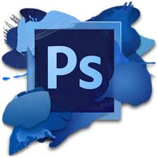
Module 1: Introduction to Photoshop
- What is Adobe Photoshop?
- Understanding raster vs vector graphics
- Photoshop interface, tools, panels, and workspace
- File formats: PSD, JPG, PNG, TIFF, GIF
- Creating and saving new documents
Module 2: Basic Tools and Operations
- Move Tool, Marquee Tool, Lasso Tool
- Crop Tool, Eyedropper Tool, Healing Brush
- Clone Stamp, Eraser, Blur, Smudge, Dodge, Burn tools
- Zoom, Hand tool, Ruler, and Guides
Module 3: Working with Layers
- Understanding Layers, Layer Panel
- Creating, deleting, linking, and grouping layers
- Layer Styles and Layer Masks
- Blending modes and opacity
Module 4: Selection Techniques
- Using Marquee, Lasso, Magic Wand, and Quick Selection
- Modify, feather, and refine selections
- Select Subject and Select & Mask
Module 5: Image Editing & Retouching
- Image adjustments: Brightness, Contrast, Levels, Curves, Hue/Saturation
- Removing spots, wrinkles, objects
- Red-eye correction
- Content-Aware Fill and Patch Tool

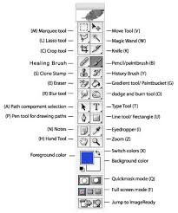
Module 6: Working with Text
- Adding and formatting text
- Warping text and text effects
- Text on a path or shape
- Paragraph and character settings
Module 7: Colors and Brushes
- Foreground and background colors
- Gradient and Paint Bucket tool
- Brush tool, brush presets and custom brushes
- Color Modes: RGB, CMYK, Grayscale
Module 8: Filters and Effects
- Applying filters: Blur, Sharpen, Noise, Distort
- Smart filters and filter gallery
- Shadows, glows, bevels, embossing
Module 9: Advanced Features
- Using Smart Objects
- Vector Shapes and Paths
- Adjustment Layers and Clipping Masks
- Using Actions and Automation
Module 10: Output and Export
- Preparing files for web and print
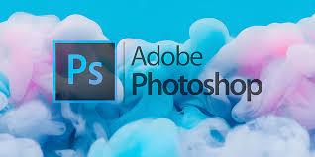
- Image optimization
- Export formats and resolution settings
- Saving for web, printing, or other applications
Project Work / Practice
- Photo Retouching
- Poster Design
- Social Media Posts
- Visiting Card or Brochure
- Background Removal
- Image Collage

